**Project Setup**

**I. Database:**

Step 1. Import the database using MySQL Workbench or PhpMyAdmin which is located inside the folder **Database**. The name of the sql file is course_website.

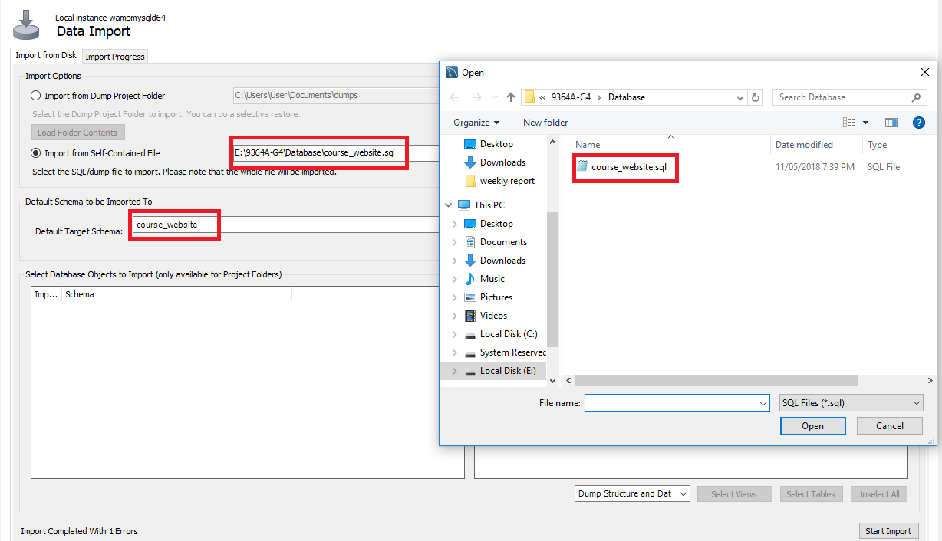

Figure 1.1

Step 2. Make sure to named the default target schema to **course_website** since there would be error if the name of the schema is different.

Step 3. We’ve also created a dummy account which will be use for logging in in our course_website. The user_name and password of the dummy account is **user1.**

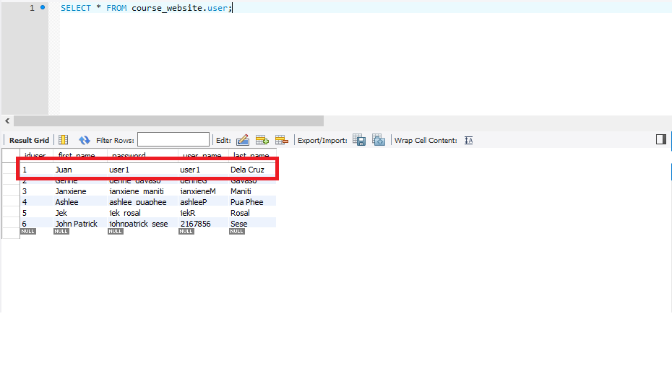

Figure 1.2

**II. Course Website**

Step 1. The folder name of our course website is named **website.** This will be hosted using WampServer.

Step 2. Copy the folder name **website** to the directory where your WampServer is located and paste it inside the **www** folder.

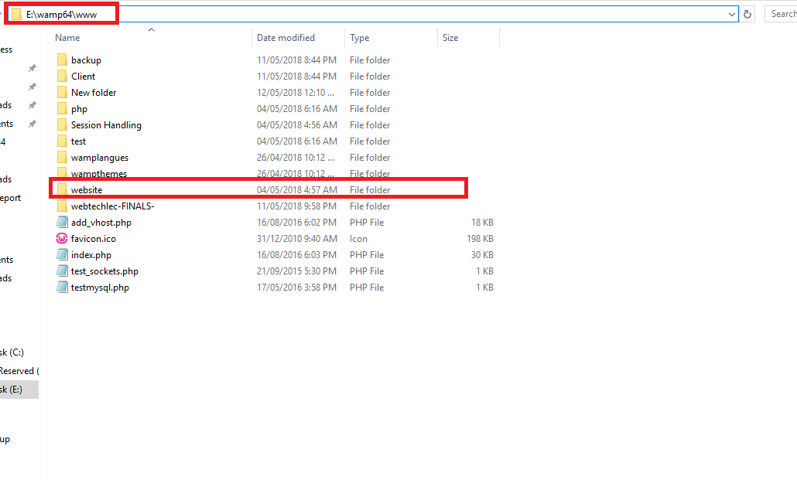

Figure 2.1

Step 3. Open any browser and type this in your browser’s search bar <http://localhost/website/>.

Step 4. It will now locate you to our login page and just enter the following username and password which is shown in Figure 1.2.

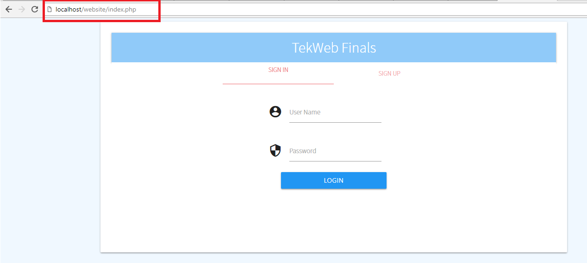

Figure 2.2